Road Traffic Collisions Analysis

Introduction
The aim of this investigation is to determine whether certain factors, such as the speed limit of a road or the time a collision occurs, can be used to predict the number of casualties, the severity, or the number of vehicles involved in a road traffic collision. This would be very useful to us as a company, as it can greatly improve our ability to predict the cost of an accident. For example, if a certain road has more than two cars involved in most of the collisions, postcodes surrounding that road could have a higher likelihood of incurring larger claims due to causing more damage.
I have chosen a dataset from the UK Government website that contains data on traffic collisions for 2023. I chose this dataset as it has many fields that are relevant to this analysis, along with an additional spreadsheet that helps decode and explain certain factors to ensure all factors are fully understood. Understanding factors fully before testing them is key to analysis, as it allows you to logically interpret results and do a sense check to see if the results are showing logical trends. For example, if the data showed that more expensive cars were costing less on first party claims, you would want to double-check the analysis is correct, as logically you expect more expensive cars to have higher repair costs.
Method
I have decided to do the analysis in a Python Jupyter Notebook as I am currently doing a lot of Python work, trying to build on my knowledge and skills. I also believe Python is a very useful tool, as it is very popular and has a wide array of packages and documentation, making it extremely versatile. I stored the dataset locally on my laptop and used Anaconda Prompt to open a Jupyter Notebook locally. I did this because the dataset I was analysing didn’t have many rows, so not much processing power would be required. This also saved time as all input data and outputs would be created and stored locally, avoiding the need for additional time to upload and download files. There are other benefits to hosting locally, such as lower costs [1], for example Kubeflow which we use costs around £2000 a month, and although not as relevant to this work as it is a publicly available dataset, you can have more control over security and privacy [1] when hosting locally.
Data Cleansing
The first step was to import any packages I might need and then import the data to allow me to start the checks. These checks include ensuring all columns are present and that all columns have the correct data types. At this stage, I also check for missing data to ensure any missing data is correctly accounted for.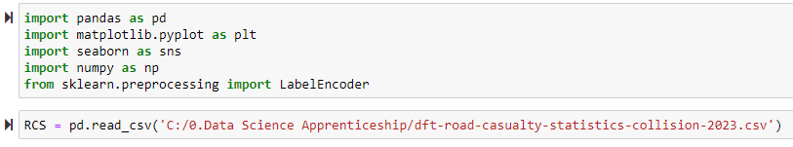
Figure 1: Code to import the packages required for this analysis and to import the data.
I imported the data using a Python package called Pandas. I called the data frame RCS for Road Collision Statistics. It is important to use shorter names that are still descriptive to save time and maintain auditable and followable code.
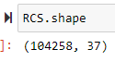
Figure 2: The code for the number of rows and columns in the dataset and its output.
The above shows me the number of rows and columns, respectively. It is important to check these numbers, as any missing rows could skew the results, and missing columns could mean losing factors that could be predictive.
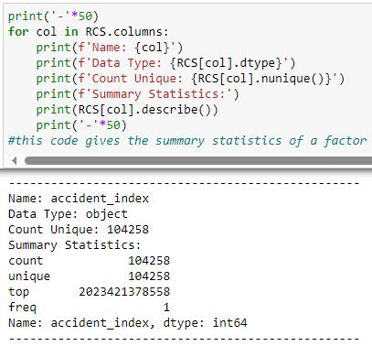
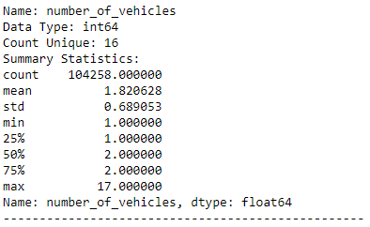
Figure 3: The code and 2 outputs for the summary statistics of the columns.
Figure 3 shows the output for two columns, illustrating the type of information I get from the code. It allows me to ensure that columns have the correct data types, sensible maximums and minimums, and the right number of rows and unique rows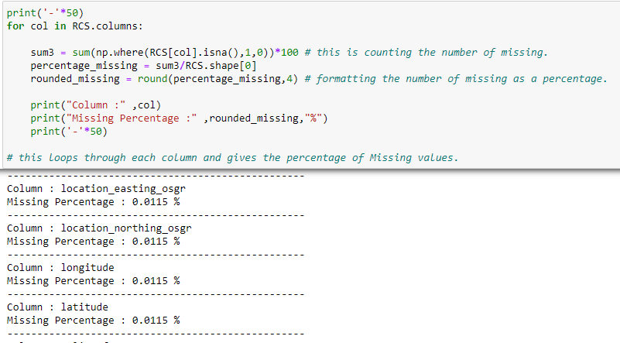
Figure 4: The code to find the percentage of missing values in a column and some examples of the outputs with the highest missing rates.
Figure 4 shows code that finds and formats the percentage of rows with missing values using the NumPy package. The only missing values belong to the fields shown above. I am not concerned about these fields as I have no plans to use them in the following analysis. If I had planned to use these fields, I would have to decide how to account for the data. There are several options. The first would be to try to find a different dataset that could be joined on that has the required fields. However, the likelihood in this case is that the data was not recorded, so I would either have to find a way to create the results myself, likely by finding the road each collision occurred on and approximating the location. This would likely be an acceptable method of replacement as the longitudes and latitudes would likely be banded into groups to ensure the data isn’t too granular. The other option would be to remove them from the data. With them being such a small percentage of the data, this would also be an acceptable solution. If the percentage of missing rows were higher, I would lean more towards the first option. However, if time were short, the second option would be more favourable.
After these checks, I was happy that the data was suitable for use. The next thing I had to decide was which columns I should test. The columns I decided to test were Time, Road Type, Speed Limit, Weather Conditions, and Road Surface Conditions. The way I would test these columns is by checking their correlation with the outcome of the collision, which I was measuring using Accident Severity, Number of Vehicles, and Number of Casualties.
The first thing I did was put the test variables and the outcome variables into lists to allow me to select them all at once for use in the analysis.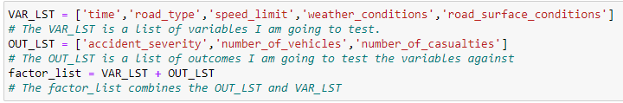
Figure 5: The code to create the lists used for plotting the graphs.

Data Analysis
I then had to get values for the correlation. There were two main correlation methods I had to decide between: Pearson and Spearman. Both methods have their advantages and disadvantages. I decided to choose Pearson for this dataset due to a few key factors. Two of Spearman’s main advantages are that it works for non-linear relationships [2] and it is robust against outliers [2]. These advantages are not very important for the dataset I am using, as there are no truly extreme outliers, as discovered in my data prep earlier, and I expect the fields I am investigating to have linear relationships for the most part, with the exception of Time and possibly speed limit as kinetic energy =0.5*Mass*Velocity^2 so it could follow that speed limit is proportional to accident severity squared. Spearman’s main disadvantages are that it is less powerful for linear data [2] and may not reflect the strength of linear relationships [2]. This makes Pearson more suitable for this analysis. In future projects, I might look to use both methods when dealing with varied datasets to ensure that data distributed differently is still accurately tested.
‌ 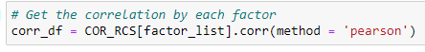
Figure 6: The code to calculate the correlation between the columns.
Now that I have the correlation calculated, I can start to visualize the data. The first thing I am going to create is a heatmap using the Seaborn package to see if there are any immediate high correlations. This works best with two contrasting colors, as this heatmap ranges from -1 to 1. I chose to go with red for 1 and blue for -1 to really highlight any differences.
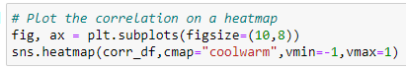
Figure 7: The code to create the heatmap shown in Figure 8
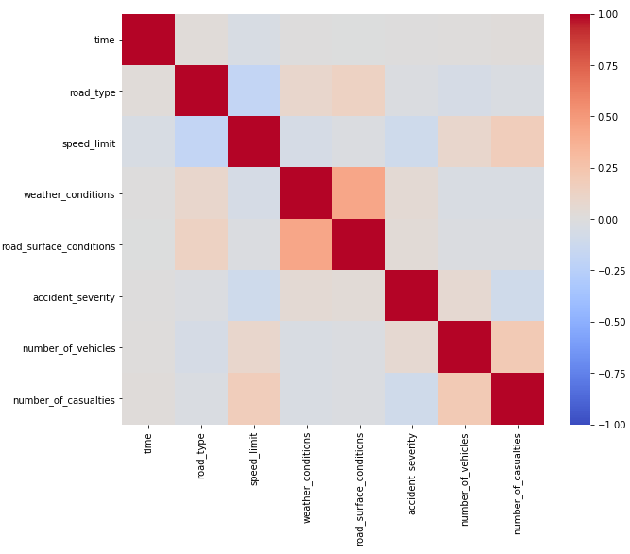
Figure 8: The heatmap of the correlation between columns created by the code in Figure 7.
The heatmap shows there is a high correlation between weather conditions and road surface conditions, which is expected as the weather likely contributed to the road conditions. In the test vs. outcome areas, however, there does not seem to be anything with a high correlation. To further test this, I will create scatterplots to see if something has been missed or if the data could be restructured to show a better linear correlation.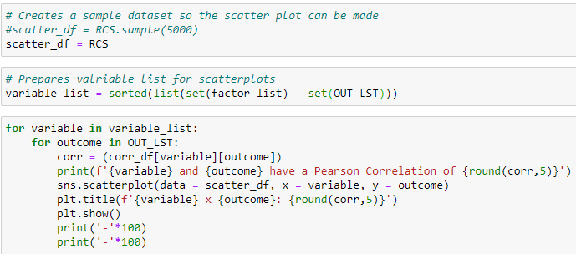
Figure 9: The code to create the scatterplots an example of which is shown in Figure 10.
The code was originally structured to take a small sample for the scatterplot to prevent overplotting. However, I decided the dataset was small enough to still see meaningful results when plotting the whole dataset.
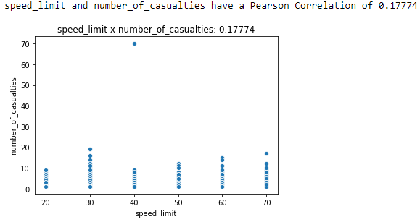
Figure 10: The distribution of Number of Casualties by Speed Limit and its correlation coefficient.

Results and Conclusion
The graph shows the plot for the number of casualties against the speed limit. As you can see, there does appear to be a trend from 40-70 mph. However, on further inspection, when 20 and 30 mph were removed along with the outlier at 40 mph, the correlation fell. The graph above showed the highest correlation, and it is a relatively weak correlation. I would consider anything with an absolute value greater than 0.4 for modelling.
This task has unfortunately yielded no results that can be useful in our models. However, it has given me further opportunities to work on my Python skills and enabled me to work with a publicly available dataset, which is not common in my day-to-day work. I think good steps in the future would be to join this dataset with some of our claims data and see if these fields are predictive on our data. This is something I may take up as a side project. This would be interesting in terms of how I would join the data. My first thought was to use the locational data to assign postcodes to each road. This would be tricky, as roads will likely stretch across multiple postcodes. I would have to use the specific location of each collision to place it in a postcode. Then, I would see if the policyholders that live in these postcodes are predictive of the crashes. This wouldn’t be perfect, as many of the people involved in the collisions may live far away. However, it could be grouped by something less granular to possibly incorporate more people who live in the area of the collisions. Another interesting avenue would be to see if any of our policy data is predictive of the severity of accidents, etc. This would likely be a waste of time as I would be loosely connecting collisions based on postcode, but if we had the data to connect these collisions to our policyholders involved, that could be very insightful.

References
[1] CSW Solutions. (n.d.). Cloud VS Local Server Hosting: Which is Best for your Data? [online] Available at: https://cswsolutions.com/blog/posts/2023/january/cloud-vs-local-server-hosting-which-is-best-for-your-data/.
[2] Amit, H. (2024). Spearman Correlation vs Pearson - Hey Amit - Medium. [online] Medium. Available at: https://medium.com/@heyamit10/spearman-correlation-vs-pearson-7471eb1d7dd8 [Accessed 4 Jan. 2025].

